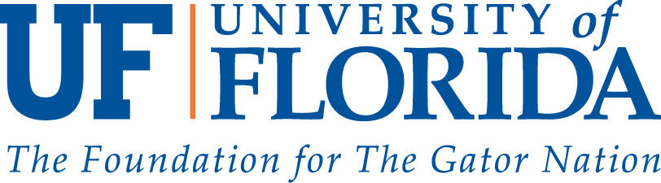 

______________________________________________________________________________________

|  |  |
| --- | --- |
| **Florida and Virgin Islands**  **Deaf-Blind Collaborative**  *1600 SW Archer Rd.*  *P.O. Box 100234*  *Gainesville, FL 32610-0234* | (352) 273-7530 (800) 667-4052  Fax (352) 273-8539  TTY (352) 846-2759  [http://www.deafblind.ufl.edu](http://www.card.ufl.edu) |

Hold the dates for the Southeast Deaf-Blind Transition Institute!



Theme: Race for the Dream: We are Limitless

Dates: June 22 – 25, 2017

Location: Alabama Institute for the Deaf and Blind, Talladega AL

If you are between 15 – 22 years of age and thinking about life after high school for employment, vocational school, or college, this is the place for you! We are looking for 3 – 4 teens/young adults and their parent to attend and gain information, contacts and support as you prepare for your future.

Family members and Teen/Young Adults will have separate training strands.

Florida and Virgin Islands Deaf-Blind Collaborative – FAVIDBC will provide:

* Travel to and from Alabama
* Registration to include: meals and lodging, training and activities
* Interpreters and Support Service Providers (SSP’s)

In Florida and USVI, Contact Emily Taylor-Snell for more information, registration and travel details. [Etsnell74@gmail.com](mailto:Etsnell74@gmail.com) or 813-817-1873 voice or text.

The registration link will be at: [www.nationaldb.org](http://www.nationaldb.org) . Deadline: April 14, 2017.